GIS-Enabled Integrated Barangay Management and Decision Support System for Barangay Conde Labac, Batangas City

A Capstone Project Presented to the Faculty of the
College of Informatics and Computing Sciences
Batangas State University – The National Engineering University
Alangilan Campus
Batangas City

In Partial Fulfillment
of the Requirements for the Degree
Bachelor of Science in Information Technology
Business Analytics

John Paul A. Arvesu
John Lex D. Bacani
Lair Broz Timothy M. Balmes

<Date>
May xxxx (Second Semester), July xxxx (Midterm Semester), and December xxxx (First Semester)
APPROVAL SHEET

This Capstone Project titled A Data-Driven Decision Support Framework for Barangay Governance Using GIS and Predictive Analytics, prepared and submitted by <First Name M. Surname>, in partial fulfillment of the requirements for the degree of Bachelor of Science in Information Technology - Business Analytics, is hereby accepted.

<Fn MI. Ln, Title Case, (bold)>
Adviser

Approved by the Committee on Oral Examination with a grade of __________.

< Fn MI. Ln, Title Case, Bold >
Chair, Defense Panel

< Fn MI. Ln, Title Case, Bold > < Fn MI. Ln, Title Case, Bold >
Panel Member Panel Member

Accepted and approved for the degree of Bachelor of Science in Information Technology - <Track>.

Date Dean, CICS
ABSTRACT
In the rural barangay of Batangas City, Barangay Conde Labak with 2,438 people and 360 hectares, the traditional and paper-based approaches to the management of public safety and social welfare resulted in disjointed and disconnected data and slow reaction to emergencies and the ability to identify vulnerable groups during humanitarian crises. . Any available electronic tools provided storage but lacked analytical or decision support functions, limiting barangay officials' ability to perceive spatial risks and other community concerns. This research sought to conceptualise, build, and deploy a Geographic Information System (GIS) integrated, cloud-based Integrated Barangay Management and Decision Support System (IBM-DSS) for Barangay Conde Labak to digitise administrative processes, enhance data management and support data-driven decision-making through spatial analytics and predictive analytics. The system was built using the Agile Scrum methodology, which follows an iterative, sprint-based development process to enable incremental improvements based on feedback. The system used HTML, CSS, JavaScript, and Leaflet.js for the user interface (UI), PHP with the Laravel framework for the backend server and application programming interface (API) management, PostgreSQL database with PostGIS extension for relational and spatial data storage. The system also incorporated Python libraries (scikit-learn and spaCy) through a Flask or FastAPI microservice for predictive analytics and sentiment analysis of resident feedback and incident reports. The use of HTTPS,JSON Web Token Authentication, Bcrypt password encryption, and Role-Based Access Control were put in place and ensured safety and compliance with the Data Privacy Act of 2012. The last system incorporated resident information, certificate processing, blotter entries and mapping Geographic Information Systems into a single system, which enabled officials to geotag households, map hazard prone locations, and find the vulnerable populations like the elderly, individuals with disabilities and social welfare beneficiaries in real time. Machine learning models were used to analyse historical incident and demographic data to detect trends and guide governance strategies, and automated certificate and blotter processes automated administrative tasks. The system that is developed has been able to digitize barangay activities, enhance disaster preparedness and offer evidenced-based governance thereby satisfying the overall purpose of the study.

DEDICATION

This section is optional. The author may dedicate the study to individuals who inspired and supported the completion of this research.

ACKNOWLEDGMENT

The completion of this study would not have been possible without the guidance, support, and encouragement of several individuals and institutions.

The author may express gratitude in a sincere and professional manner.

If your study is supported by an agency, include the following statement:

I would like to acknowledge the support of the <name of agency, client> for the assistance in the completion of the study.

If this is part of a funded research project, include the following statement:

This study is one of the outputs of the research project entitled: <title of the project> funded by <name of the funding agency>.

If you are a recipient of scholarship, include the following statement:

This study is part of the benefits of the scholarship entitled <name of the scholarship> funded by <name of the funding agency>.

TABLE OF CONTENTS
1. INTRODUCTION 11
1.1 Background of the Study 12
1.2 Objectives of the Study 14
1.3 Scope and Delimitations 15
1.4 Significance of the Study 17
1.5 Definition of Terms 19
2. LITERATURE REVIEW 21
2.1 Related Systems 21
2.2 Related Technologies 30
2.3 Conceptual Framework 42
3. METHODOLOGY 45
3.1 Research Design 45
3.2 Client Requirements Analysis 47
3.2.1 Client Profile 47
3.2.2 Current System Analysis 48
3.2.3 Problem Identification 50
3.2.4 Functional Requirements 52
3.2.5 Non-Functional Requirements 53
3.2.6 System Context 54
3.3 System Architecture 55
3.4 AI Integration Design 57
3.5 Development Tools and Technologies 60
3.6 Implementation Procedure 64
3.7 Testing and Evaluation 68
3.8 Evaluation Methods 73
3.9 Ethical Considerations 74
4. RESULTS AND DISCUSSION 76
4.1 System Presentation 76
Includes: 76
Guidelines: 76
4.2 Testing and Evaluation Results 77
Includes: 77
Evaluation Metrics (as applicable): 77
Guidelines: 77
4.3 Analysis of Results 78
Includes: 78
Guidelines: 78
Note (For Figures and Diagrams): 79
5. SUMMARY, CONCLUSIONS AND RECOMMENDATIONS 80
5.1 Summary 80
Includes: 80
5.2 Conclusions 80
Guidelines: 80
Important Rule: 81
5.3 Recommendations 81
General Note 81

LIST OF TABLES

Insert the List of Tables using the “References” tab > “Insert Table of Figures” > Table

LIST OF FIGURES
Figure 1 41
Figure 2 48
Figure 3 49
Figure 4 52
Figure 5 53
Figure 6 54

1. INTRODUCTION
This chapter presents the context of the problem, the needs of the client, and the proposed system.

1.1 Background of the Study
Barangay Conde Labac is a rural area in Batangas City which has a hectare of 360.0214 with a population of 2,438 residents. The barangay being the most localized unit of government in the Philippines is the one that provides the necessary public services, peace and order, social welfare programs and organizes the disaster preparedness activities. Irrespective of these important roles, the Barangay Council of Conde Labac was still using the outdated systems of administration, which were paper-based. Physical logbooks and handwritten forms were used to maintain resident profiles, record certificate requests and document incident records, which were the traditional methods of local governance that several barangays throughout the country used.
The use of manual processes presented a number of operational constraints which compromised the efficiency and reliability of barangay services. Physical records were susceptible to loss or destruction by fire, flooding and other disasters and a systematic backup and recovery system was not in place. Errors in data entry, duplicate records as well as inconsistency of information also complicated the ability to retrieve the correct details of residents when required. More importantly, these solitary paper-based records formed disjointed data landscapes in which information could not be simply cross-referenced or analyzed, rendering it virtually impossible to find and defend vulnerable populations, like elderly and individuals with disabilities and welfare recipients, in case of an emergency. Available digital tools to similar barangay units were in most cases restricted to simple storage of records, and lacked any type of spatial analysis or decision-support.
The implications of these restrictions were not just a nuisance to the administration, but the quality of governance and safety outcomes to the community themselves. The officials of Barangay failed to recognize the households located in the hazard-prone areas, track the patterns of recurrence of the incidents in various parts of the barangay, and even predict the concerns of the community before it turned into bigger issues. The lack of analytical tools implied that the decision-making process was more reactive than proactive, and the officials reacted to the issues only after they happened. The time-consuming task of certificate processing, which mandated manual search and validation of resident records, was taking up a lot of staff time that could be channeled to community activities and service delivery.
These operational loopholes created a decisive and pressing requirement of a technology-oriented solution that would not only digitize barangay records but convert crude information into intelligence that could be used. An internet-based application that can streamline resident data, incident reports and administrative processes into one secure and convenient system will directly deal with the inefficiencies that manual record-keeping brings. In addition, with the implementation of Geographic Information System technology, spatial mapping of household locations, hazard areas, and vulnerable population clusters would be possible, which will provide the officials with the geographic background that is required to plan their resources allocation and emergency response.
In order to work on these needs, the study came up with the proposal of coming up with a Geographic Information System enabled Integrated Barangay Management and Decision Support System to Barangay Conde Labac. In addition to digitization, the system included artificial intelligence elements, such as predictive analytics and sentiment analysis, to help with evidence-based governance. Predictive models constructed based on past incidence and demographic information enabled officials to establish emerging trends and predict the problems that would affect the communities, whereas natural language processing tools examined feedbacks left by residents to bring out repeated issues. A combination of these features moved the barangay dynamic stance to data-driven governance response rather than reactive response, which satisfied the requirement of a modern, intelligent and scalable local government management platform.

1.2 Objectives of the Study

This paper was intended to design, develop and implement an Integrated Barangay Management and Decision Support System with Geographic Information System capabilities to enable Barangay Conde Labac, Batangas City to digitize its administrative processes, enhance data management, and make data-driven decisions based on data analysis and predictive analytics.
In particular, the research aimed to:
- Establish a single, automated, centralized records management on resident information, certificate issuance and blotter management to be accurate, consistent and efficient in data retrieval as an alternative to the manual and paper-based system of the barangay.
- Incorporate geotagging and spatial mapping with Geographic Information System to visualize the locations of households, areas prone to hazards and vulnerable population groups that include senior citizens, persons with disabilities, and welfare beneficiaries to aid better emergency response and allocation of resources.
- Add predictive analytics and sentiment analysis based on historical incident data and user feedback to detect trends, predict community concerns, and allow barangay officials to take proactive evidence-based actions.
- Test the system developed and assess its acceptability by conducting user acceptance testing with barangay officials and staff and quantify the usability, functionality, accuracy, and overall effectiveness of the system in overcoming the operation constraints in Barangay Conde Labac identified during the initial stages of this project.

1.3 Scope and Delimitations
The research involved the design, development, and deployment of an Integrated Barangay Management and Decision Support System using Geographic Information System, specifically meant to serve Barangay Conde Labac, Batangas City. The system featured a centralized digital record-keeping facility for resident profiles, certificate issuance, and blotter or incident reporting, replacing the manual, paper-based operations of the barangay. It included a Leaflet.js-powered, OpenStreetMap-based Geographic Information System mapping module which allowed household geotagging, visualization of hazard zones, and spatial identification of vulnerable population groups including the elderly, people with disabilities, and welfare recipients. An artificial intelligence feature was also integrated through the Google Gemini API, which performed sentiment classification of resident feedback and generated decision-support summaries derived from historical incident data to provide actionable insights for barangay officials. The system further included an analytics dashboard to present these insights in an easy-to-understand graphical format. Three user roles were defined — residents, barangay officials, and administrators — with specific access levels implemented through Role-Based Access Control. Security features such as HTTPS encryption, JSON Web Token authentication, Bcrypt password hashing, and audit trail logging were implemented in compliance with the Data Privacy Act of 2012. The system was deployed on a local Apache web server hosted at the barangay hall, with an offsite backup solution through cloud storage facilities.
The research was confined solely to the operations of Barangay Conde Labac and was not intended to be implemented or reproduced in other barangays or local government units without further tailoring. The AI-generated insights produced by the Gemini API were dependent on the volume and quality of locally available incident and feedback data, and their reliability may vary as data accumulates over time. The system did not include real-time integration with external government databases, national disaster risk reduction agency platforms, or other inter-agency information systems. Mobile application development was outside the scope of the study, as the system was built as a web-based platform accessible through standard internet browsers. The sentiment analysis feature was limited to text-based feedback submitted through the system and did not extend to social media monitoring or other external communication channels. The procurement of hardware, upgrades to network infrastructure, and the provisioning of internet connectivity at the barangay hall were also considered beyond the scope of the study.

1.4 Significance of the Study
The development of the GIS-Enabled Integrated Barangay Management and Decision Support System will directly benefit barangay officials, residents, and the wider community of Barangay Conde Labac.
For barangay officials and staff, the system will address the most time-consuming parts of daily administrative work. Verifying a resident's identity before issuing a certificate currently requires searching through physical logbooks, a process that can take hours. The system will reduce that to a database query. More practically, the GIS map and analytics dashboard will give officials something they currently lack: a data-based picture of what is happening across the barangay. Which areas have recurring incident clusters? Which households fall within flood boundaries? Which demographic groups will need priority attention during an emergency? These are questions the paper-based setup cannot answer, and the proposed system will be able to.
For residents, the most immediate benefit will be faster service. Certificate processing will no longer require long waits while staff manually pull paper records. Beyond speed, the spatial mapping feature will allow barangay responders to accurately locate vulnerable households elderly residents, persons with disabilities, and 4Ps beneficiaries during emergencies. Residents will also be able to file incident reports and submit feedback directly through the system, giving them a traceable channel to raise concerns rather than a verbal report that may go unrecorded.
For future researchers and developers, the study will contribute a documented implementation of GIS, predictive analytics, and sentiment analysis in a barangay governance context using an open-source technology stack. Researchers working on local e-governance and developers adapting the system for similar communities will be able to reference both the architecture and the implementation approach.
The project will also support SDG 11 (Sustainable Cities and Communities) through improved disaster preparedness and inclusive service delivery at the barangay level, and SDG 16 (Peace, Justice and Strong Institutions) through stronger data accountability and administrative capacity at the local government level.

1.5 Definition of Terms
Agile Scrum. An iterative software development framework in which the system's features are built and tested in short, structured cycles called Sprints, with stakeholder feedback used to guide revisions between cycles.
Blotter Management. A digital module that allows residents to file incident reports through the system and enables barangay officials to log, update, monitor, and resolve those reports through a centralized database.
Decision Support System. A computer-based platform that processes resident, incident, and spatial data from Barangay Conde Labac to produce analytical outputs that help officials make informed governance decisions.
Geographic Information System (GIS). A spatial mapping technology used in this study to display household locations, hazard-prone areas, and the distribution of vulnerable population groups — senior citizens, persons with disabilities, and welfare beneficiaries — on an interactive map.
Geotagging. The process of assigning geographic coordinates to a household or incident record so that it can be located and displayed on the system's GIS map.
PostGIS. A spatial extension for PostgreSQL that stores and queries geographic data, used in this system to manage household coordinates and hazard zone boundaries.
Predictive Analytics. The application of the Gemini API to process historical incident and demographic data from Barangay Conde Labac to provide barangay administrators and officials with trend-based insights and decision support summaries to anticipate and address community needs and inform proactive governance strategies.
Role-Based Access Control (RBAC). A security mechanism that restricts each user's access to specific system modules based on their assigned role, with separate permission levels for residents, barangay officials, and administrators.
Sentiment Analysis. A natural language processing method implemented using the Google Gemini API that classifies resident feedback as positive, neutral, or negative, allowing officials to identify and prioritize recurring community concerns.
Sprint. A fixed development cycle within the Agile Scrum framework during which a defined set of system features is built, tested, and reviewed before the next cycle begins.

2. LITERATURE REVIEW

2.1 Related Systems
E-Barangay: A Framework for a Web-Based System for Local Communities and Its Usability
According to Bringula et al. (2022), the e-Barangay framework was developed to address the lack of community-level e-governance systems, as most existing frameworks focus on municipal or national levels. The study proposed a web-based platform designed specifically for barangay operations, incorporating core functionalities such as filing complaints, requesting documents, submitting suggestions, and posting announcements. The system was evaluated using both objective and subjective usability measures, which showed favorable results and indicated that the platform effectively met the needs of local stakeholders. The study highlights the importance of tailored e-governance solutions at the barangay level, emphasizing usability, accessibility, and community engagement as key factors in system adoption. However, despite its strong focus on community-based service delivery and usability, the system is limited by its lack of advanced data analytics and decision-support capabilities. It does not incorporate Geographic Information System (GIS) features, which are essential for spatial mapping and identifying hazard-prone areas and vulnerable populations. Additionally, the system lacks predictive analytics and artificial intelligence integration, preventing it from analyzing trends or generating actionable insights for proactive governance. These limitations highlight the need for a more advanced system that integrates GIS, predictive analytics, and intelligent decision-support mechanisms, which the proposed study aims to address.

One Barangay: A Mobile And Web Barangay Management System
According to Jamis et al. (2022), the One Barangay system was developed as a mobile and web-based platform to address the challenges of managing barangay records and services using manual tools such as spreadsheets and paper-based documents. The system provides centralized data storage, allowing barangay officials to manage resident information, process requests, and organize records efficiently through a digital interface. It improves accessibility and data security while enabling better coordination of community services. The implementation demonstrated improved productivity and more systematic handling of barangay data, particularly during situations such as the COVID-19 pandemic where digital access became essential. However, the system is primarily focused on data management and administrative digitization, with limited support for advanced analytics, GIS-based spatial mapping, or predictive decision-making. It does not provide tools for analyzing trends or identifying risk-prone areas geographically. Additionally, the system lacks AI-based insights that could enhance proactive governance. These limitations highlight the need for a more advanced system that integrates GIS and predictive analytics, which the proposed study aims to address.

Development and Implementation of an Office Automation System for Barangay Local Government Units
According to Dela Cerna (2023), an office automation system was developed to improve clerical processes in barangay local government units by digitizing document management, transaction processing, and administrative workflows. The system enables faster processing of records, reduces manual errors, and improves overall efficiency in handling barangay services. By replacing traditional paper-based systems, the platform enhances transparency and productivity in local governance operations. Despite these improvements, the system is limited to basic office automation and document processing, lacking data analytics, GIS integration, and predictive capabilities. It does not provide insights into community patterns, risk areas, or resident behavior, which are essential for decision-making. Additionally, the system remains reactive rather than proactive, as it does not support forecasting or intelligent analysis. These gaps indicate the need for a more intelligent system that incorporates analytics and spatial technologies, as proposed in this study.

Enhanced Barangay Information Management System with Residency Certificate Issuance
According to Dela Cruz et al. (2023), an enhanced Barangay Information Management System was developed to improve administrative efficiency by automating residency certificate issuance and maintaining a centralized repository of barangay records. The system allows barangay officials to manage resident information, process certificates, and streamline document handling through a digital platform. It was evaluated using the USE (Usefulness, Satisfaction, Ease of Use) model and achieved a high acceptance rating, indicating that the system significantly improves usability and operational efficiency in barangay governance. The system demonstrates how digital transformation can simplify administrative workflows and improve service delivery in local government units. However, the system is primarily focused on administrative automation and record management, with limited support for spatial analysis or advanced decision-support capabilities. It does not incorporate Geographic Information Systems (GIS) or predictive analytics, which are essential for identifying risk-prone areas and forecasting community trends. Furthermore, the system lacks AI-driven insights that could enhance proactive governance. These limitations highlight the need for a more advanced system that integrates spatial intelligence and predictive analytics, which the proposed study aims to address.

Digital Barangay: Ayos Lomboy’s Web-based Management and Information System
According to Gasmido et al. (2025), a web-based barangay information system known as Webyu was developed to automate workflows, centralize data, and improve service delivery in barangay operations. The system uses Agile Scrum methodology and was evaluated using ISO 25010 quality standards and the Technology Acceptance Model (TAM), achieving high scores in usability, performance, and user acceptance. It enables efficient data management, reduces processing time, and enhances accessibility of barangay services for both officials and residents. However, the system focuses mainly on process automation and data management, with limited integration of advanced analytics, GIS mapping, or AI-driven decision support. It does not provide predictive insights or spatial visualization features that are essential for identifying risk areas and supporting proactive governance. These limitations highlight the need for a more advanced system that integrates GIS and predictive analytics, as proposed in this study.
BarangayConnect: A Web-Based Information Portal for Resident Data, Administrative Services, and Community Records Using Data Analytics and Linear Regression Algorithms
According to Enano et al. (2025), BarangayConnect is a web-based information portal designed to manage resident data, administrative services, and community records using data analytics and linear regression algorithms. The system centralizes barangay operations by allowing officials to store and retrieve resident profiles, process administrative requests, and analyze community data through an integrated platform. A key feature of the system is its use of linear regression to analyze trends in barangay data, enabling officials to gain insights into patterns that can support planning and decision-making. The platform enhances administrative efficiency and promotes data-driven governance by transforming traditional manual processes into a structured digital system. Despite its incorporation of data analytics, the system is limited by its reliance on basic statistical methods such as linear regression, which may not fully capture complex patterns in community data. It lacks advanced AI capabilities such as natural language processing for sentiment analysis and does not integrate spatial mapping or Geographic Information Systems, which are critical for identifying location-based risks and vulnerabilities. Furthermore, the system focuses more on data processing and storage rather than comprehensive decision-support mechanisms. These limitations emphasize the need for a more robust system that combines GIS, predictive analytics, and AI-assisted insights, which the proposed study aims to achieve.
B-GIS: Modernizing Local Governance Through a Web-Based Barangay Geographic Information System for Barangay 99, Tondo, Manila
According to the study of Del Pilar et al. (2024), the B-GIS system was developed as a web-based Geographic Information System designed to modernize barangay governance by integrating spatial mapping with administrative functions. The system enables barangay officials to manage resident records, visualize geographic data, and monitor community information through an interactive mapping interface. It incorporates GIS features such as spatial visualization of barangay zones and supports administrative operations including record management and reporting, thereby improving accessibility and efficiency in local governance processes. The system demonstrates how integrating GIS into barangay systems can enhance decision-making by providing geographic context to community data. However, despite its strengths, the system is primarily focused on data visualization and administrative digitization, with limited support for advanced analytics or predictive decision-making capabilities. It does not incorporate AI-driven features such as sentiment analysis or predictive modeling, which are essential for proactive governance. Additionally, the system lacks deeper integration of behavioral or incident-based analytics that could help identify patterns over time. These limitations highlight the need for a more advanced platform that not only visualizes spatial data but also transforms it into actionable intelligence, which the proposed study aims to address through the integration of predictive analytics and AI-assisted decision support.

Enhancing Barangay Safety: Leveraging Convolutional Neural Networks for Comprehensive Detection of Brawling Incidents in Philippine Barangays
According to Escobañez et al. (2024), a barangay safety monitoring system utilizing convolutional neural networks (CNN) was developed to detect brawling incidents and enhance public safety in local communities. The system applies computer vision techniques to analyze visual data and identify violent behavior in real time, allowing authorities to respond quickly to incidents. This approach demonstrates the potential of artificial intelligence in improving safety monitoring and incident detection in barangays. However, the system focuses primarily on incident detection using visual data and does not integrate administrative management, GIS mapping, or comprehensive decision-support features. It operates as a standalone safety monitoring tool rather than a unified governance system. Additionally, it lacks integration with resident data and broader community analytics, limiting its applicability for holistic barangay management. These limitations highlight the need for an integrated system that combines safety monitoring with administrative and spatial intelligence, which the proposed study aims to achieve.

GIS-Based Analysis Of Disaster Risk Reduction Strategies
According to Aedla et al. (2025), Geographic Information Systems (GIS) play a critical role in enhancing disaster risk reduction (DRR) strategies by enabling the analysis, visualization, and management of hazard-related data. The study highlights the application of GIS across different stages of disaster management, including preparedness, response, and recovery, through the integration of spatial data such as geographic maps, demographic information, and hazard indicators. By using GIS, decision-makers are able to assess risk-prone areas, evaluate disaster impacts, and plan appropriate interventions more effectively. The study also demonstrates how GIS has been successfully applied in various global disaster scenarios, improving resource allocation and strengthening disaster preparedness efforts However, despite its strong capabilities in spatial analysis and disaster modeling, the study is limited by its lack of integration with administrative systems and real-time governance operations. It does not include modules for resident data management, incident reporting, or service processing, which are essential in barangay-level systems. Additionally, while the study suggests future integration of artificial intelligence and machine learning, it does not fully implement predictive analytics or AI-driven decision-support features. These limitations highlight the need for a more comprehensive system that integrates GIS with administrative functions and intelligent analytics, which the proposed study aims to address.
Web-based Election Monitoring Integrating Barangay Geospatial Mapping
According to Salubre et al. (2022), a web-based election monitoring system integrating barangay geospatial mapping was developed to improve the visualization and accessibility of election results in the Philippines. The system utilizes web technologies, cloud infrastructure, and open-source tools to transform election data obtained from the Commission on Elections (COMELEC) into graphical representations such as charts, graphs, and geographic maps. By incorporating geospatial mapping, the system allows users to view voting results at the barangay and municipal levels with greater clarity and accuracy. The implementation demonstrated faster data encoding, verification, and dissemination of election results, enhancing transparency and improving public trust in the electoral process through real-time visual reporting. However, despite its strong capabilities in data visualization and geospatial mapping, the system is limited to election monitoring and does not support broader barangay administrative functions. It lacks integration with resident data management, incident reporting, and service processing modules, which are essential in barangay governance systems. Additionally, the system does not incorporate predictive analytics or AI-driven decision-support features, focusing primarily on real-time data presentation rather than analysis and forecasting. These limitations highlight the need for a more comprehensive system that integrates geospatial mapping with administrative operations and intelligent analytics, which the proposed study aims to address.

2.2 Related Technologies
This section presents the technologies, tools, frameworks, and platforms used in the design and development of the GIS-Enabled Integrated Barangay Management and Decision Support System for Barangay Conde Labac. Each technology was selected based on its direct relevance to the system’s functional requirements, its proven effectiveness in comparable local government and information system deployments, and its alignment with the Business Analytics track of the Bachelor of Science in Information Technology program. The following discussion covers ten core technologies that collectively enable the system’s capabilities across spatial data management, web-based administration, artificial intelligence, and data security.
HTML and CSS
The user interface of the system is designed and developed using HyperText Markup Language (HTML) and Cascading Style Sheets (CSS). HTML organizes and semantically defines all the pages of the user interface, including barangay resident dashboards, applications for certificates, and administrative dashboards. CSS is responsible for the presentation of the user interface, which provides aesthetic, accessible, and consistent features to the look and feel of the interface in the different modules and devices.
In an IEEE conference paper on intelligent scene recognition, Pan and Ma (2022) verified the use of HTML and CSS as the most popular technologies to create intuitive and flexible interfaces to develop accessible and aesthetically appealing user interfaces, making them perfect for an interactive and responsive system. In this project, the use of HTML and CSS in particular is essential in ensuring resident-focused functionalities, such as the application for certificates and the resident feedback form, are intuitive and accessible to reduce the chances of user error and allow efficient administrative processing as noted by Dela Cruz et al. (2023).

Bootstrap CSS Framework
Bootstrap is an open-source, mobile-first CSS framework that provides a comprehensive collection of pre-built responsive components, grid systems, and utility classes for constructing consistent and accessible user interfaces across different screen sizes and devices. In the proposed system, Bootstrap is applied across all frontend views the resident dashboard, barangay officials' analytics panel, certificate issuance module, and administrator interface to ensure that the layout adapts reliably to desktops, tablets, and mobile phones without requiring custom responsive CSS to be written for each module. This is particularly important for a barangay-level deployment where officials and staff may access the system from a variety of devices, including smartphones, during field operations or emergency response situations.
Dela Cruz et al. (2023) employed Bootstrap as the primary responsive UI framework in their enhanced barangay information management system and confirmed in their IEEE conference study that its grid-based layout significantly reduced development time for multi-module local government systems while maintaining interface consistency across user roles. Gasmido et al. (2025) similarly integrated Bootstrap in the Webyu barangay management platform and reported that its pre-built component library contributed directly to the system's high usability ratings under ISO 25010 evaluation, as staff with limited technical backgrounds were able to navigate the interface with minimal training. Finding that directly supports Bootstrap's selection for the proposed system, whose target users include barangay personnel with varying levels of digital literacy.
JavaScript
The system’s frontend is largely developed using JavaScript, the main scripting language. It facilitates client-side form validation, asynchronous calls to the Laravel-based server, and interactive map controls using Leaflet.js. JavaScript is also used to dynamically update the analytics dashboard so that barangay officials can see insights generated by the AI system, heat maps of the incidents, and distribution of residents without having to refresh the entire page. Its capability to interact with the backend APIs via asynchronous requests is crucial to the integration of all frontend modules with the system's server-side components. The importance of JavaScript in modern web-based governance systems is well-established. Enano et al. (2025) employed JavaScript as a core frontend component in BarangayConnect, a web-based information portal for resident data and administrative services that demonstrated measurable improvements in administrative efficiency using data analytics. Similarly, Altura et al. (2023) utilized JavaScript in a web-portal health information system for barangays and confirmed through their IEEE conference study that dynamic scripting significantly improved the usability and responsiveness of community-facing digital services. These precedents validate JavaScript’s selection as an essential technology in the proposed system.
PHP with Laravel Framework
PHP is a widely used server-side scripting language that underpins the backend logic of the system, while the Laravel framework provides a structured and maintainable Model-View-Controller (MVC) architecture for managing API endpoints, routing, authentication, and business logic. Laravel handles all server-side operations including certificate issuance workflows, incident report management, user authentication via JSON Web Tokens, and communication with the PostgreSQL database. Its built-in support for RESTful API construction allows the frontend and the Python-based AI microservice to interact with the backend in a standardized and secure manner.
Lim (2022) showed how a Barangay Integrated Management System, based on a PHP and MySQL architecture, is highly usable and efficient in centralizing data between barangay office and barangay health center. It was emphasized in the study that these types of integrated systems are highly usable, secured as well as efficient and provide a rapid and effortless method of managing resident profiles, document requests and health records and produce meaningful administrative reports. With an equally integrated strategy, the proposed system will help Barangay Conde Labak step outside the realm of manual transactions and adopt a digital framework that enables both web-based administration and mobile accessibility of the residents. Jamis et al. (2022) similarly employed PHP and Laravel as the backend framework for the One Barangay platform, an IEEE conference study that demonstrated the viability of Laravel-based architectures for managing complex multi-module barangay management systems.
Leaflet.js for GIS and Spatial Mapping
Leaflet.js is an open source, browser based and lightweight JavaScript library that is used to create interactive geographic maps in the web browser. Leaflet.js is the central element of the proposed system that will visualize geotagged locations of households, barangay hazard zones, the distribution of incidences on the map, and the spatial distribution of the vulnerable population, i.e. senior citizens, persons with disabilities, and beneficiaries of 4Ps. It is especially compatible with OpenStreetMap which offers a free and open-source basemap, rendering it ideal to a deployment on the barangay level, where cost in licensing needs to be kept to a minimum. The Leaflet.js further allows rendering of GeoJSON data directly queried in PostGIS spatial queries, and allows the creation of dynamically constructed maps based on data.
Del Pilar et al. (2024) employed Leaflet.js as the primary mapping library in B-GIS, a web-based barangay geographic information system presented at an IEEE international conference, and demonstrated that it effectively modernized local governance by enabling spatial visualization of resident and hazard data within a barangay context. Nerona et al. (2026) further affirmed in their journal study on improving data management systems for a local government unit in Baguio City that GIS-enabled mapping tools are essential for enhancing sustainable public service delivery, particularly in communities with complex geographic and demographic profiles such as Barangay Conde Labac.
PostgreSQL with PostGIS
PostgreSQL is the host Relational Database Management System (RDMBS) that stores all relational data in the proposed system, such as resident information, certificates, incident reports, user accounts, and community responses. The PostgreSQL database with the PostGIS extension supports native spatial data types and spatial query functions, enabling the system to store households' GPS coordinates, define the boundaries of areas prone to certain hazards, and execute spatial queries, such as finding all households within a flood-prone area or the closest evacuation center to a specific coordinate. This allows us to remove the geographic information system (GIS) data processing layer and to store and query spatial and relational data in the same database.
In particular, Fronda et al. (2025) identified PostgreSQL with PostGIS as a key technology for CBDRR in communities in Batangas, stating in their IEEE conference paper that "spatial database support is essential for identifying vulnerable households and emergency response planning in the Philippines".. Duco et al. (2023) also verified the use of spatial databases with PostGIS in barangay-based systems for disaster response management, confirming that it will satisfy the geographic data needs of the proposed system, which requires geo-referencing all households in Barangay Conde Labac and linking household data with hazard zones.
Google Gemini API for AI-Assisted Decision Support
The Google Gemini API serves as the primary engine for the system's artificial intelligence capabilities, specifically for automated sentiment classification of resident feedback and complaint records, and for generating decision-support summaries from historical incident data. Rather than training custom machine learning models from scratch, the system calls the Gemini API directly from the Laravel backend using Laravel's built-in HTTP client, allowing barangay officials to receive AI-generated interpretations of community sentiment and actionable governance recommendations without requiring data science expertise. This approach reduces development complexity while delivering high-quality natural language understanding capabilities that are accessible to non-technical government personnel.
Verma (2022) conducted a comprehensive literature review published in Government Information Quarterly on the application of sentiment analysis to public service evaluation and found that AI-assisted sentiment classification produces actionable intelligence for government decision-making that manual analysis cannot replicate at scale. This finding directly supports the integration of the Google Gemini API as a decision-support tool in the proposed system. Furthermore, Enano et al. (2025) demonstrated in their study of BarangayConnect that AI-assisted data analytics, including linear regression algorithms applied to community records, significantly improves the capacity of barangay systems to generate evidence-based insights for administrative planning.
OpenStreetMap as Basemap Provider
The system uses OpenStreetMap (OSM) as basemap for all the map views rendered by Leaflet.js. As OpenStreetMap is a free, open-source, community driven world map, it provides comprehensive street and geographical data about Barangay Conde Labac and its vicinity in Batangas City without licensing and API subscription fees. Leaflet.js directly connects with OpenStreetMap tile servers to display base map layers that are used as foundations for the system to overlay geotagged markers of households, hazard zones, and heat maps. The adoption of OpenStreetMap enables the system to run without any recurrent map generation expenses, enabling affordable deployment in the limited budget of a rural barangay.
Del Pilar et al. (2024) in particular, used OpenStreetMap as the base map provider for the B-GIS system and verified in their IEEE conference paper that the Leaflet.js map viewer and OpenStreetMap basemap together offer a cost-effective, fully operational geographic information system that can support the spatial needs of barangay governance without the need for commercial map licenses. Nerona et al. (2026) also confirmed the importance of open-source maps as a platform for sustainable deployment of a GIS-powered local government information system for Filipino communities who may not afford to pay for commercial geographic data subscriptions in the long run. The research by Jiménez-Espada et al. (2023) supports the selection of OpenStreetMap as a basemap provider by demonstrating that GIS-integrated tools are essential for local managers to identify spatial imbalances and evaluate community sustainability. By providing free, community-driven geographical data, OpenStreetMap serves as the necessary foundation for Leaflet.js to visualize key sustainability factors, such as population distribution and facility accessibility, without the burden of commercial licensing fees. This open-source approach mirrors the study's conclusion that accessible GIS data provides "invaluable information" for public administration, enabling even resource-constrained local units to maintain a functional decision support system. Ultimately, utilizing OpenStreetMap allows for the sustainable implementation of the study's methodology by providing an affordable platform to monitor urban morphology and implement corrective measures within the communit
Chart.js for Data Visualization
Chart.js is a JavaScript library that renders AI-supported insights, past incident trends and demographic data as interactive visual dashboards for barangay officials and administrators. In the system, Chart.js generates bar, line, pie, and other types of data visualisations based on resident data, incident records, and community feedback sentiment scores. These visual representations enable non-technical users to readily understand the outputs of data analytics and to draw insights such as seasonal crime spikes, repeating incidents and shifts in the vulnerable population - thus supporting evidence-based decision making without having to review tables of data.
Enano et al. (2025) implemented data visualisation components similar to Chart.js in BarangayConnect and noted that the visualisation of community analytics greatly enhanced the understanding and application of system insights among barangay employees, demonstrating that visual dashboards are crucial for turning data analytics into governance measures. Duco et al. (2023) similarly found in their IEEE conference study that web analytics dashboards with visual chart components were among the most valued features of their barangay services platform, as they enabled officials to monitor community trends and allocate resources more effectively compared to traditional textual report formats.

JWT Authentication and Role-Based Access Control (RBAC)
The system primarily employs JSON Web Tokens (JWT) and Role-Based Access Control (RBAC) for security to protect the privacy of resident data, and to enforce access control among users of the system. JWT is used to implement stateless API authentication; once logged in, a user gets a digitally signed and unique token that is checked every time the user makes an API request without having to store user sessions on the server, which improves speed and scalability RBAC provides varying access rights at both the application and database levels, so that residents are only able to view their own records and request services, barangay officials are able to manage reported incidents and approve certificates, and system administrators can manage users, archives, and system settings.
Nugraha et al. (2023) conducted a performance and security comparison between JWT and Platform-Agnostic Security Tokens on RESTful APIs and found that while JWT demonstrated faster token generation and transfer times, it showed vulnerability to Broken User Authentication attacks such as header algorithm exploitation and token payload decoding. This finding is acknowledged in the design of the proposed system, and it is addressed through the implementation of strict token expiration policies, secure token storage practices, and layered access control through RBAC to reduce the risk of token misuse. Moreno and Zabala (2023) also stressed in their research on the digitalization of local government units in the Philippines that authentication and access control are essential minimum standards for any digital government system handling citizen personal data, as their absence poses both legal and public trust risks for local government units, particularly in relation to compliance with Republic Act 10173, also known as the Data Privacy Act of 2012.
Bcrypt Password Hashing
Bcrypt is the password hashing algorithm, which is used to safely store all the user credentials in the database of the system. Bcrypt passwords are computedally infeasible to recover the original password even in the event of a database breach, unlike reversible encryption, which uses a password and transforms it using an adaptive one-way hash function. The algorithm includes a cost factor which can be adjusted to a tuneable constant to ensure that it is resistant to brute-force attacks as computing hardware advances. In the suggested system, Bcrypt will be used to encrypt the passwords of all user accounts of residents, barangay officials and administrators so that exposure of credentials by any breach of databases will not lead to unauthorized access to resident records and administrative capabilities.
This practice corresponds to security constructs of Imus et al. (2022), that requires a security layer to ensure that records of communities cannot be accessed by unauthorized digital intrusion. This is supported by Gallera and Salvador (2023) who state that such cryptographic standards adoption is a practical requirement to the local government units to make sure that their information systems are not only reliable but also in accordance with existing privacy requirements. Combining these insights, the system can make sure that sensitive profiling data is kept secure and offer a transparent and efficient service to the community.

Apache Web Server
The web server that will be deployed in the proposed system will be the Apache HTTP Server to host the system on-premise at the barangay hall of Barangay Conde Labac. All incoming HTTP and HTTPS requests by client browsers are handled by Apache and passed onto the Larval application, such as serving the static assets (JavaScript files, CSS stylesheets, map tile caches) and passing the dynamic processing of PHP calls onto the application layer. The benefit of having the system hosted on a local Apache server is that the main administrative functions will continue to run even in the event of an internet outage, which is especially crucial when it comes to a barangay located in a disaster-prone area where connectivity is likely to be lost at the same time that an emergency response is most required. The maturity and stability of Apache along with its detailed documentation make it a safe bet when it comes to a government server environment with limited IT maintenance resources.
Moreno and Zabala (2023) emphasized in their study of municipal government digitalization in the Philippines that on-premise server deployments are often more operationally appropriate than fully cloud-hosted solutions for rural local government units, as they ensure system availability independent of internet connectivity and reduce ongoing subscription costs. A major benefit of this local hosting strategy, as investigated by Boligor et al. (2024), is that the key administrative tasks will not be affected by internet downtime. This is an important level of reliability and availability especially in a barangay located in a disaster prone region where communication and response to an emergency is most crucial at the very point when connectivity may be lost. Moreover, the proven maturity and rich documentation of the Apache server offers a reliable solution to government environments with potentially limited IT maintenance.
Cloud Storage for Backup and Redundancy
Google Cloud Storage (GCS) and Amazon Web Services S3 (AWS S3) are proposed as the off-site storage solutions for the system's cloud backups, enabling a hybrid server deployment model where the main system is hosted at the barangay hall, and automatic backups of database snapshots and exports are stored in the cloud. This guarantees the safety of resident databases, incident databases, and spatial databases against fire, flood and hardware damage at the barangay hall, which is particularly important in a hazard-prone Barangay Conde Labac.
Fronda et al. (2025) noted in their IEEE conference study on community-based disaster risk reduction in Batangas that data loss prevention through redundant storage is a critical component of governance system resilience in hazard-prone Philippine communities, affirming the necessity of offsite cloud backup for a system serving Barangay Conde Labac. Nerona et al. (2026) similarly confirmed in their journal study that hybrid server architectures combining local deployment with cloud-based backup represent the most sustainable and resilient infrastructure model for local government information systems in the Philippines, balancing operational independence with data durability and recovery capability.

2.3 Conceptual Framework

Figure 1
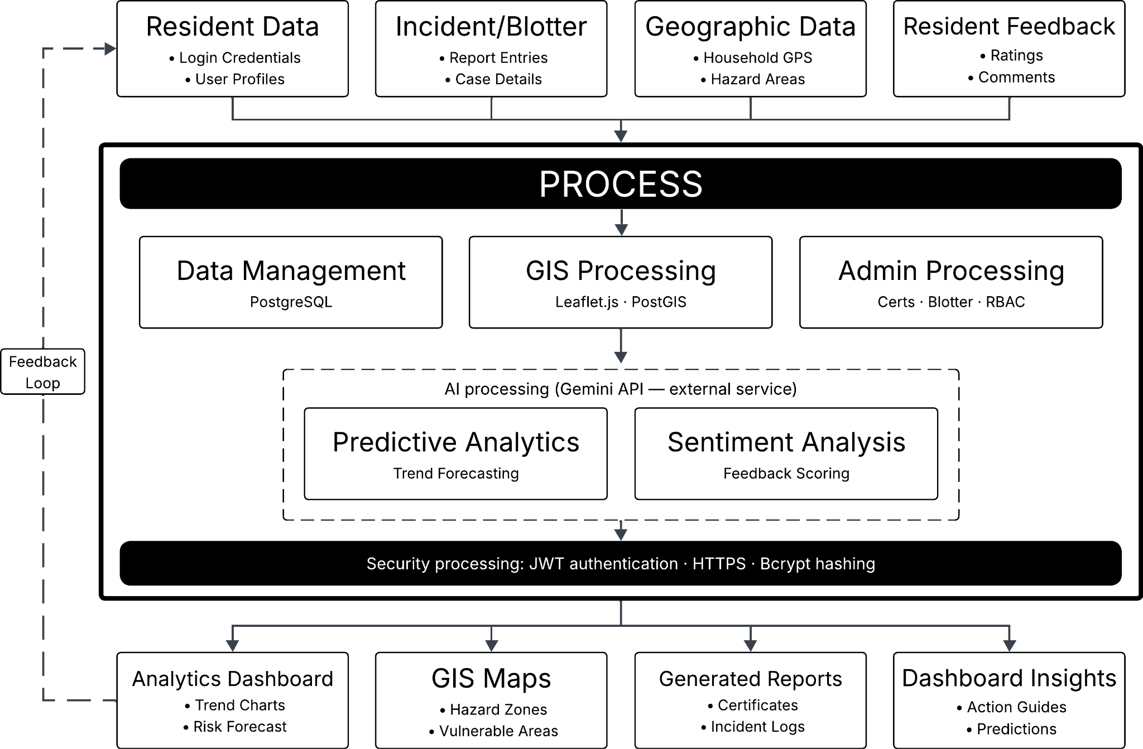
Input Process Output Diagram
The figure shows the Input–Process–Output (IPO) model to illustrate how data flows through the proposed GIS-Enabled Integrated Barangay Management and Decision Support System. The framework demonstrates how various types of input data are transformed into meaningful outputs through a series of system processes, including the integration of artificial intelligence components. This structure provides a clear representation of how the system supports data-driven governance in Barangay Conde Labac.
The input stage consists of essential data required for system operation, including resident information, incident or blotter reports, geographic data such as household locations and hazard-prone areas, and feedback from residents. These inputs serve as the foundation of the system, enabling the collection of both structured and unstructured data relevant to barangay operations and community conditions.
The process stage involves multiple system components that handle data transformation and analysis. This includes data management through a centralized database, GIS processing for spatial mapping and visualization, and administrative processing for certificate issuance and incident management. Additionally, artificial intelligence components are integrated to enhance system functionality, including predictive analytics for identifying trends and forecasting risks, and sentiment analysis for evaluating resident feedback. Security mechanisms such as authentication and data encryption are also implemented to ensure data integrity and privacy.
The output stage presents the results of the system processes in the form of an analytics dashboard, GIS-based visualizations, administrative reports, and decision-support insights. These outputs enable barangay officials to identify risk-prone areas, monitor community issues, and make informed decisions based on real-time data. A feedback loop is also incorporated, allowing outputs to be continuously fed back into the system to improve future analysis and support ongoing data-driven decision-making.

3. METHODOLOGY

3.1 Research Design
This study will adopt the Agile Scrum method for software development in order to ensure that the Barangay Officials are the focal point when it comes to the design and development of the GIS-Enabled Integrated Barangay Management and Decision Support System. This helps the officials to constantly prioritize features that meet the administration and analysis requirements of Barangay Conde Labac. The system will be developed beginning with a Problem Identification and Analysis phase, during which the study team will engage in extensive consultations with the Barangay Chairperson, Council Members, and staff. They will share their experience of the population density, vulnerabilities to hazards, and time to response, which will be incorporated into the Product Backlog, prioritising the features that address the operational challenges identified by the local officials.

The next phase, Technology Selection and System Design, will determine the system infrastructure needed to assist the officials' decision-making. The system will contain a powerful stack, with the spatial database PostgreSQL with PostGIS for spatial data. To keep the design user-friendly, technical diagrams (system architecture, data flow) will be reviewed by the Barangay Council. This will ensure proposed digital processes align with real-world barangay administrative processes and legal frameworks before development commences.

System Development and Testing will be conducted in Sprints and will be reviewed by Barangay Officials at each review. Barangay Officials will use these Sprint Reviews to try out the functional snapshots and give feedback, which will be incorporated into the remainder of the Product Backlog. This iteration ensures that the system's security features (Role-Based Access Control (RBAC) and Bcrypt hashing) align with the council's requirements and data security standards for resident data, in line with the Data Privacy Act of 2012. Through this iterative process with the officials' involvement, the system will be fine-tuned to their governance and peace-and-order requirements.

The last stage, Deployment and Evaluation, will include the installation of the developed system on the central server of the Barangay Hall. The Barangay Officials and staff will act as the final testers in User Acceptance Testing (UAT), assessing the system's effectiveness to ease operational problems and its user-friendliness. The predictive analytics will be tested against historical data to ensure the officials have accurate data for future planning. As a sustainability measure, the project ends with a training program to equip the Barangay staff to manage the system as a long-term, evidence-based decision support system for its community.

3.2 Client Requirements Analysis
This section presents the analysis of the client’s current system, including the client profile, existing setup, requirements, and identified problems. It serves as the basis for designing the proposed system.

3.2.1 Client Profile
Barangay Conde Labac is a barangay in Batangas City, Batangas, Philippines. It has a total land area of 360.0214 hectares and a population of 2,438 as of 2010. The barangay, as the most basic unit of government in the Philippines, is responsible to provide basic services to its constituents, ensure law and order, lead disaster preparedness and mitigation activities and implement social welfare programs. The Barangay Council, which is made up of elected officials and appointed personnel, handles the administration of the community and is responsible for the well-being and security of all the residents living within its boundaries.
Barangay Conde Labac's current administrative system is paper-based. Barangay records such as resident profiles, certificate applications, incident and blotter reports, and other documents are stored in logbooks and printed forms located at the barangay hall. The community does not yet have a digital platform or information system to store, manage and analyse these data. Barangay staff process all transactions, such as certification and incident reporting, manually, and there is no automated, digital process, backup or data analytics currently in place to support administrative processes and governance decision-making.

3.2.2 Current System Analysis
The current manual operational procedure of Barangay Conde Labac is completely manual. If a resident needs a barangay certificate, for example, the barangay personnel manually look up the resident's identity and status in the physical logbook. The certificate is then manually written or printed and given to the applicant. For incident or blotter reports, a resident or complainant physically visits the barangay hall to report an incident, and the designated personnel manually enter it in a logbook. Barangay officials periodically review these records, but there is currently no way to monitor the history of incidents, detect trends, or compile statistical summaries for planning and evaluation. Similarly, resident profiling is also done manually, with data collected through door-to-door visits and manually entered into paper forms, which are then kept in filing cabinets in the barangay hall. Resident data is updated only when residents inform barangay officials of changes in their status, which means that the information is often out-of-date. During emergencies or disasters, barriers result from having to search through paper files to locate vulnerable residents and households, which is inefficient and inaccurate under time pressures.

Figure 2
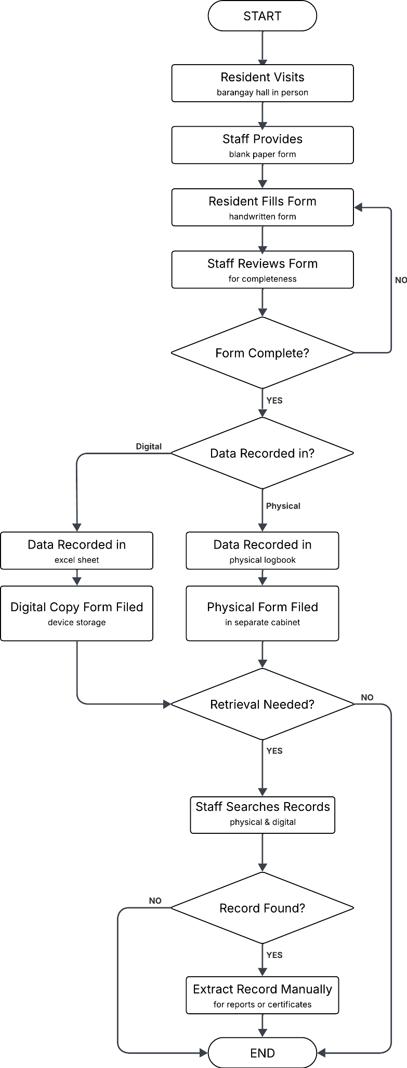
Existing System Process Flow
The diagram above shows the current manual, step-by-step workflow of Barangay Conde Labac in processing its regular administrative transactions. Begins when a resident physically visits the barangay hall to request a service, at which point staff provides them with a blank paper form. The resident must complete this form by hand, after which it undergoes a manual review by staff to ensure all required fields are filled; if incomplete, the resident is sent back to redo the form. Once verified as complete, the process branches into two separate, non-integrated recording streams: data is either recorded in a physical logbook with the paper form filed in a cabinet, or it is entered into an Excel sheet with the digital copy saved on local device storage. When a resident later requires a report or certificate, staff must manually search through these disjointed physical and digital records to retrieve the necessary information. If the record is successfully located, the data is extracted manually to produce the final document, a step that frequently leads to significant delays and potential errors due to the lack of a centralized, searchable database.

3.2.3 Problem Identification
Based on the analysis of the current system, the following problems were identified:
Through an analysis of the existing system, the following issues were identified:
- The lack of a centralised electronic database led to scattered and inconsistent resident data that was hard to access, update, and integrate for various administrative transactions.
- Hard-copy records maintained in logbooks and filing cabinets were prone to destruction in the event of fire, floods, and other calamities, without a backup and data restoration system to safeguard vital barangay data.
- The time and manpower required to process certificate and blotter reports increased processing time and created a bureaucratic burden for barangay personnel.
- The absence of spatial information capabilities meant officials could not map household locations in areas at risk of natural and man-made disasters, or determine the locations of vulnerable residents (elderly, persons with disabilities and welfare beneficiaries) in times of crisis.
- In the absence of analytical tools, officials were unable to identify patterns of incidents, predict and assess risks in the community, or analyze citizen responses to service delivery, leaving them to rely on observation and experience rather than data in governance decision-making.
- The lack of real-time monitoring and data analysis meant the barangay could only respond to problems after they happened, which left the barangay to work in a reactive rather than proactive manner.

3.2.4 Functional Requirements

Figure 3
Use Case Diagram
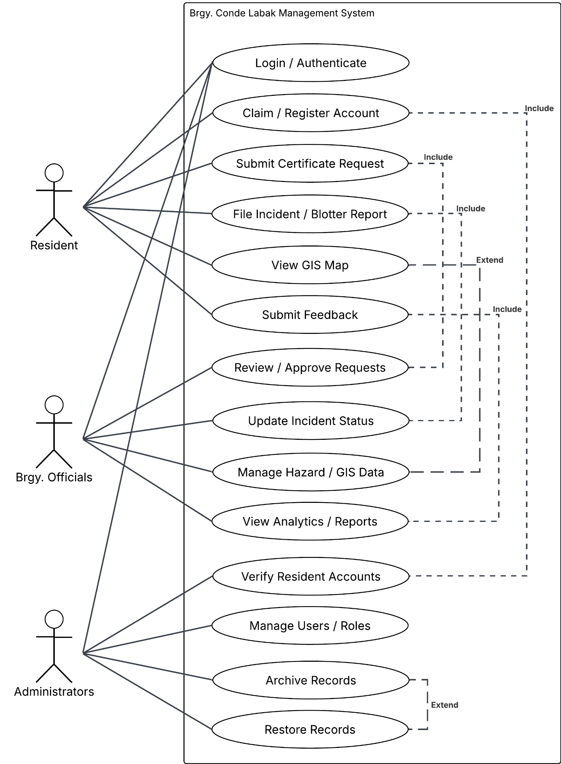
The use case diagram above presents the functional scope of the proposed system from the perspective of its three primary users. Residents are shown interacting with modules for account claiming, certificate requests, incident reporting, map viewing, and feedback submission. Barangay officials are depicted with access to certificate approval, incident status management, hazard data viewing, and analytics insights. The administrator is shown with exclusive control over user account management, role assignments, and the archive and restore process. The diagram establishes clear boundaries between user roles and confirms that the system's functional requirements are fully aligned with the operational needs of each stakeholder group.

3.2.5 Non-Functional Requirements
The proposed system will meet the following non-functional requirements to ensure its reliability, security, usability and sustainability as a governance system for Barangay Conde Labac.
Regarding performance, the system will be able to manage multiple simultaneous user sessions without any performance bottleneck. The system will employ efficient and fast database queries, certificate generation and map rendering to provide timely responses within expected response times.
In terms of security, the system will use HTTPS and SSL certificates to secure data communication between the client browser and server. We will use JSON Web Token for secure authentication, and Bcrypt for password hashing. A user audit trail will be maintained with timestamps and user IDs to track user activity. All this will be done in accordance with Republic Act 10173, or the Data Privacy Act of 2012.
As for reliability, the system will have an auto offsite backup feature that will allow the resident, incident and spatial data to be retrieved in the case of hardware, power and physical damage to the barangay hall. The system will ensure data integrity and consistency for all modules using database integrity and validation rules.
For usability, the system user interface will be built using Bootstrap to provide a mobile-responsive, consistent and accessible design across all devices. The workflows of the modules will be designed to be intuitive in order to reduce the training time for the barangay staff and officials with varying levels of technical expertise.
When it comes to scalability, the system will be scalable to support the growth of resident, incident, and spatial data. The system will be able to scale up storage capacity and new system modules through the cloud-based backup system and PostgreSQL database.

3.2.6 System Context

Figure 4
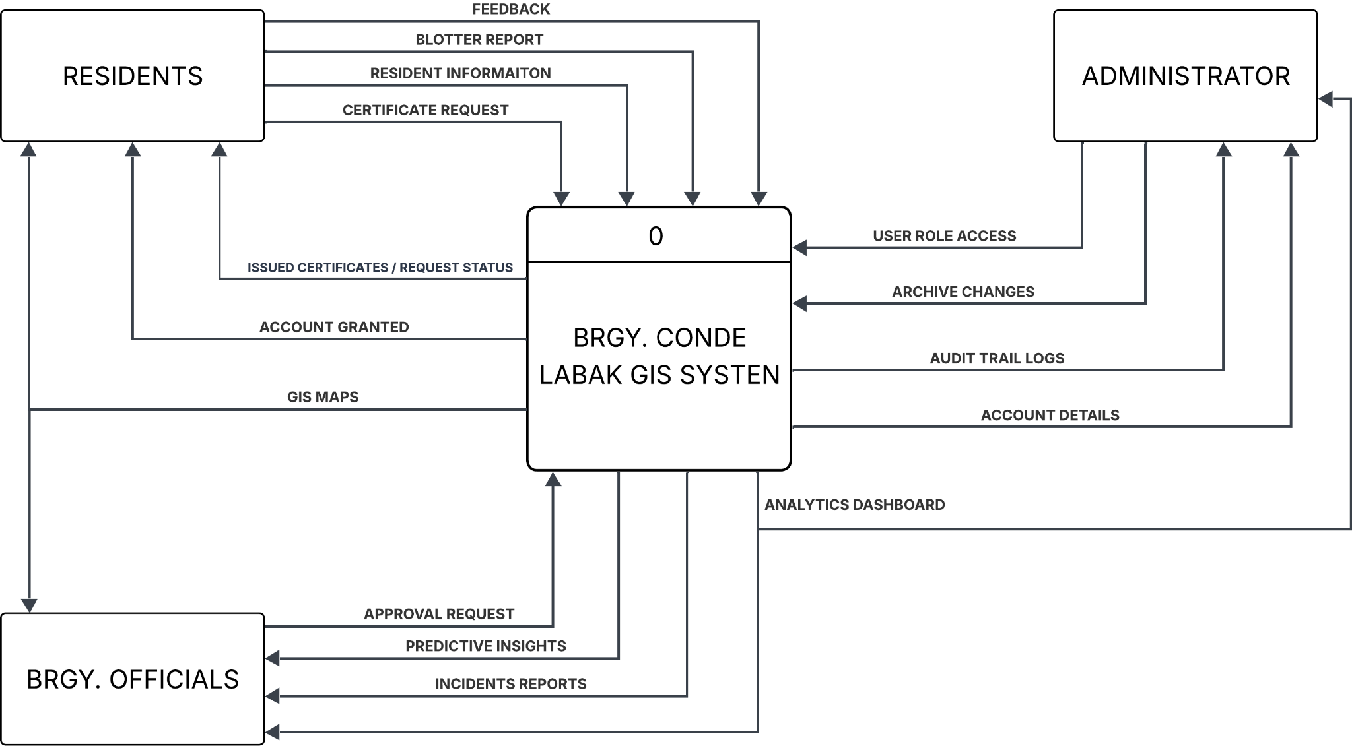
Context Diagram
The system context of the proposed Geographic Information System-based Integrated Barangay Management and Decision Support System establishes the scope and interactions of the system with the outside world. The system has three main external users - residents, barangay officials and the administrator - who exchange information with the system in a purposeful manner as per their roles and responsibilities.

3.3 System Architecture
This is a web-based, cloud-assisted governance platform designed to replace manual, paper-based barangay processes with a centralized, digitized, and AI-assisted system. It supports both day-to-day administrative operations and evidence-based decision-making by combining geographic information, resident data, and AI-driven analytics into a single integrated platform enabling barangay officials to manage their community more efficiently and respond to issues proactively.

Figure 5
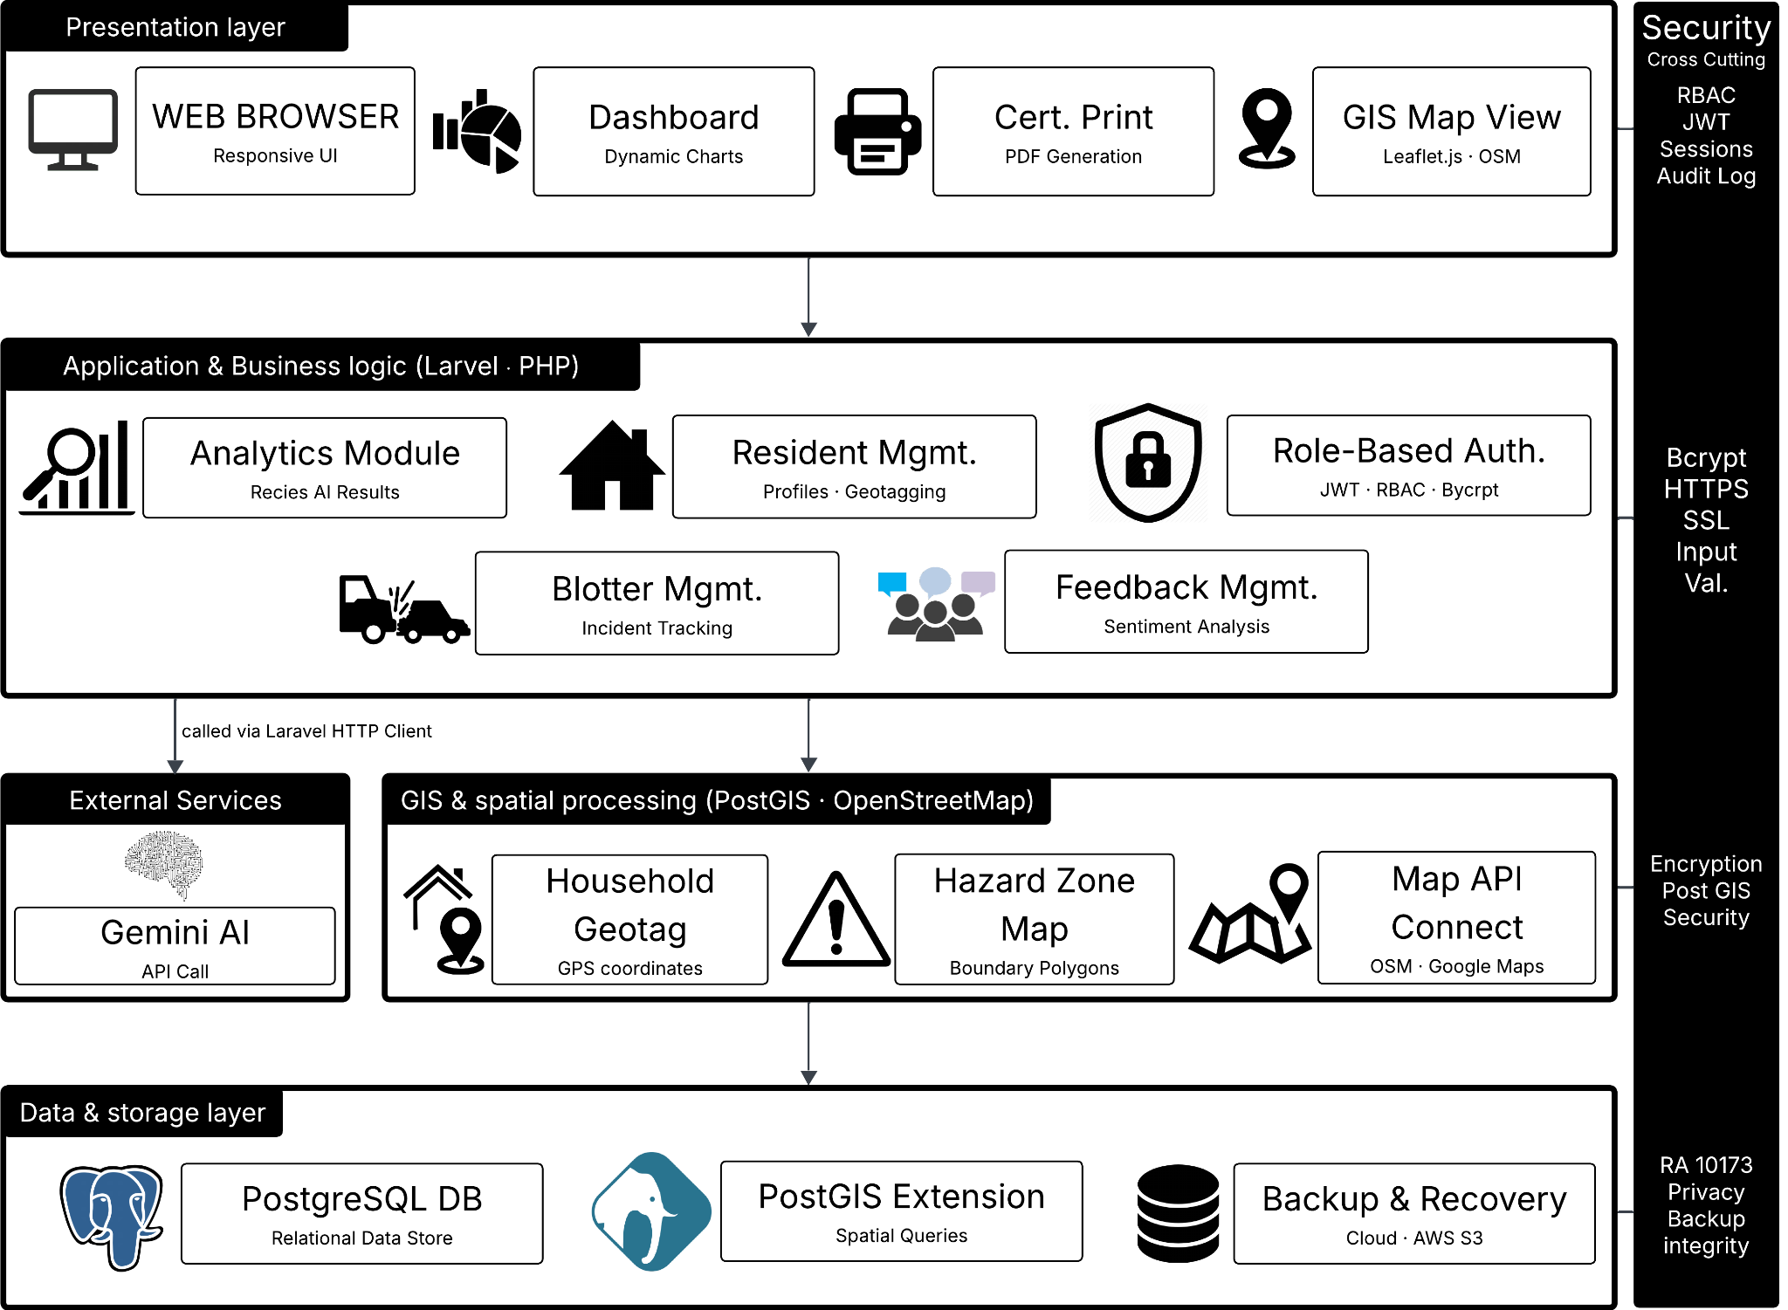
Architecture Diagram
The system is built across four layers with a unified security perimeter. The Presentation Layer delivers the user interface dynamic dashboards, a certificate print module, and an interactive GIS map view rendered via Leaflet.js. Below it, the Application and Business Logic Layer handles all core operations through a Laravel and PHP backend, including resident management, blotter tracking, feedback handling, and role-based authentication. The GIS and Spatial Processing Layer manages household geotagging, hazard zone boundary mapping, and map API connections through PostGIS and OpenStreetMap. At the base, the Data and Storage Layer persists all records in PostgreSQL with the PostGIS extension for spatial queries and AWS S3 for offsite backup. Security covering RBAC, JWT, Bcrypt, HTTPS/SSL, audit logging, and RA 10173 compliance is enforced across every layer.

Figure 6
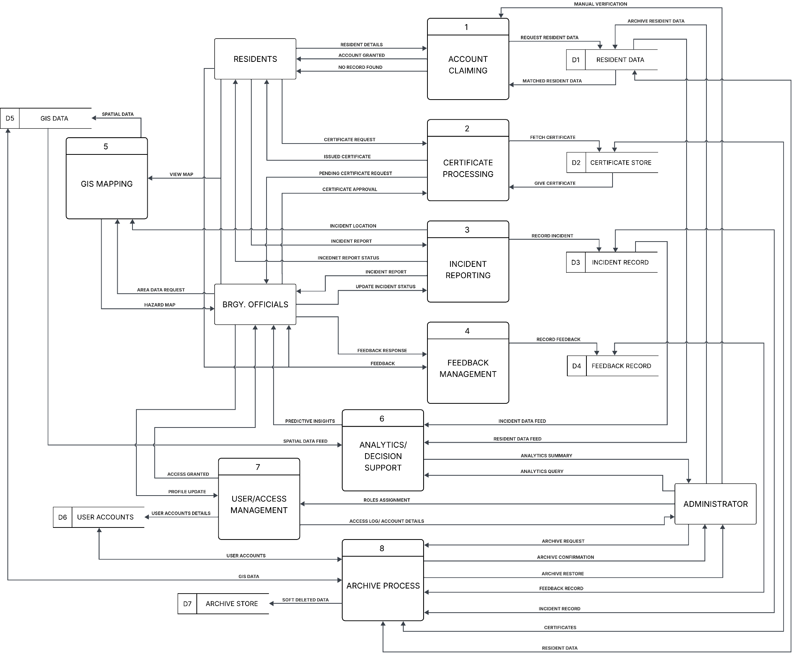
Level 0 Diagram
The system manages eight interconnected processes across three user roles — Residents, Barangay Officials, and an Administrator. Residents can claim digital accounts, request barangay certificates, file incident or blotter reports, submit community feedback, and view the GIS map. Officials handle certificate approvals, update incident statuses, monitor hazard areas, and receive AI-generated analytics summaries and predictive insights drawn from incident records, resident data, and feedback. The Administrator oversees user access and role assignments, performs manual account verification, and manages the archiving and restoration of all system records. Running across all of this is a Gemini AI integration that automatically performs sentiment analysis on resident feedback and surfaces decision-support insights from historical data, turning raw records into actionable intelligence for officials.

3.4 AI Integration Design
Purpose of AI Features

The system integrates the Google Gemini API as its core AI component to shift barangay governance from reactive to proactive. The Gemini API serves three primary functions within the platform. First, it performs sentiment classification of resident feedback and complaints submitted through the system, automatically categorizing submissions as positive, neutral, or negative so that officials can quickly surface and prioritize urgent community concerns without manually reviewing every entry. Second, it generates automated decision-support summaries for barangay officials by processing structured context drawn from historical incident data stored in the PostgreSQL database, identifying patterns across time, location, and demographic groupings, and producing plain-language insights that support evidence-based resource allocation and emergency response planning. Third, the system generates trend-based predictive advisories by feeding structured, time-aggregated incident data from the PostgreSQL database into the Gemini API via a structured Laravel prompt. The API processes historical patterns of incident frequencies by type, zone, and time period and returns plain-language forecasts identifying which community concerns are likely to escalate, enabling officials to act proactively rather than reactively. Together, these three functions convert raw operational data into actionable intelligence, directly supporting the system's goal of data-driven local governance. The use of a large language model for this purpose aligns with the findings of Fajardo et al. (2024), who demonstrated that AI-assisted analytics within Philippine LGU contexts produce reliable and interpretable outcomes for governance decision-making.

Method of Integration

The Gemini API is called directly from the Laravel backend using Laravel’s built-in HTTP client, requiring no separate runtime, language bridge, or intermediate microservice. When an AI-assisted operation is triggered — such as the submission of new resident feedback or a request to generate a decision-support summary on the analytics dashboard — the Laravel controller constructs a structured prompt that embeds the relevant data retrieved from the PostgreSQL database and dispatches it to the Gemini API endpoint via an authenticated HTTP POST request. The API returns a JSON response containing the model’s output, which Laravel parses and routes to the appropriate frontend view for display. This architecture keeps the AI integration entirely within the existing PHP stack, simplifying deployment, reducing infrastructure overhead. All Gemini API requests are handled server-side, ensuring that API credentials are never exposed to the client and that all data transmitted to the model passes through the same security and validation layer that governs the rest of the application.

AI Tools and APIs Used

● Google Gemini API — large language model used for sentiment classification of resident feedback and automated generation of decision-support summaries for barangay officials
● Laravel HTTP Client — built-in Laravel feature used to dispatch authenticated POST requests directly to the Gemini API endpoint and parse the returned JSON responses.
● PostgreSQL + PostGIS — primary data source from which incident records, resident demographics, and spatial data are retrieved and structured into prompts supplied to the Gemini API

3.5 Development Tools and Technologies
Programming Languages
● HTML & CSS — for structuring and styling the frontend interface of the system, ensuring a clean and accessible user interface across all modules
● JavaScript — for frontend interactivity, map rendering, and dynamic dashboard components
● PHP — for server-side backend development, widely used in local government and academic systems in the Philippines, practical for a barangay-level deployment
● SQL — for database queries and management across PostgreSQL

Frameworks
● Bootstrap (CSS Framework) — for responsive and consistent UI styling across all pages of the system
● Leaflet.js — lightweight JavaScript library specifically for rendering interactive maps, compatible with OpenStreetMap which is free and open source
● Laravel (PHP) — backend framework for building the REST API, handling routing, authentication, and business logic in a structured and secure manner
● Gemini AI API — for AI-assisted sentiment classification and decision-support insight generation based on resident feedback and historical incident data, called directly from the Laravel backend via HTTP client

Databases
● PostgreSQL — primary relational database for storing all structured data including residents, certificates, incidents, feedback, and user accounts
● PostGIS — PostgreSQL extension that adds spatial and geographic data support, essential for storing and querying household coordinates, hazard zones, and GIS data

Development Tools
Visual Studio Code (VS Code) — primary Integrated Development Environment used throughout the project for writing, debugging, and maintaining the system's codebase. Its support for PHP, JavaScript, Python, and SQL through extensions such as IntelliSense and its built-in Git integration for version control made it suitable for managing the system's multi-language stack within a single workspace.

Frontend technologies
- HTML / CSS / JavaScript — the core building blocks of the system's web interface; handles structure, styling, and interactivity on the client side
- Bootstrap — responsive UI framework that ensures the interface adapts cleanly across different screen sizes and devices
- Leaflet.js — powers the interactive GIS maps using OpenStreetMap, used to display household locations, hazard zones, and incident heatmaps
- Chart.js — generates the data visualization dashboards that display analytics and reports for barangay officials

Backend technologies
- PHP + Laravel — the core backend framework that handles REST API routing, authentication, and all business logic; also the layer through which the Gemini API is called
- PostgreSQL — the main relational database that stores all structured data including resident records, blotter entries, and certificate information
- PostGIS — an extension on top of PostgreSQL that enables geographic queries such as locating households within hazard zone boundaries
- Google Gemini API — the AI integration that classifies sentiment from resident feedback and generates decision-support summaries for barangay officials
- Apache web server — serves the system on-premise at the barangay hall itself as the local deployment environment
- Google Cloud Storage / AWS S3 — used for offsite backup of barangay data to ensure continuity in case of local server failure
- Cloudflare — sits in front of the system to handle DNS management and provide DDoS protection

AI Tools and APIs Used
● Google Gemini API — large language model used for sentiment classification of resident feedback and automated generation of decision-support summaries for barangay officials
● Laravel HTTP Client — built-in Laravel feature used to dispatch authenticated POST requests directly to the Gemini API endpoint and parse the returned JSON responses.
● PostgreSQL + PostGIS — primary data source from which incident records, resident demographics, and spatial data are retrieved and structured into prompts supplied to the Gemini API

3.6 Implementation Procedure
The implementation of the GIS-Enabled Integrated Barangay Management and Decision Support System followed a structured, phase-based development procedure aligned with the Agile Software Development Life Cycle adopted in Section 3.1. Each phase was executed sequentially, with the outputs of each stage serving as inputs to the next, while iterative client feedback loops were maintained throughout. The following subsections describe the sequence of development activities, system development stages, and integration process carried out during the construction of the proposed system.
- Phase 1: Requirements Gathering and Environment Setup
The first phase involved the conduct of structured interviews and document review sessions with barangay officials and staff of Barangay Conde Labac to validate and finalize the functional and non-functional requirements identified during the client requirements analysis. Following requirements confirmation, the development environment was configured. This included the installation and setup of Visual Studio Code as the primary Integrated Development Environment, Composer for PHP dependency management, Node.js and npm for frontend package management, PostgreSQL with the PostGIS extension for spatial database operations, and the Apache HTTP Server for local system hosting. The Laravel framework was initialized via the Laravel installer, and the project repository was created and version-controlled using Git. API credentials for the Google Gemini API were obtained from Google AI Studio and stored as environment variables within the Laravel application's .env configuration file.
  - Phase 2: Database Design and Backend Development
The second phase focused on the design of the relational and spatial database schema and the development of the system's backend logic. The PostgreSQL database was structured to accommodate resident profiles, certificate issuance records, blotter and incident reports, community feedback entries, and spatial household coordinates. PostGIS geometry columns were defined for all location-bearing entities to support GIS querying and mapping operations. Laravel database migrations were written and executed to generate all required tables, and Eloquent ORM models were created for each entity. RESTful API routes and controllers were implemented for all core modules, including resident management, certificate processing, and blotter recording. JSON Web Token authentication was integrated using the Laravel JWT package, and Role-Based Access Control policies were defined and applied to enforce user-level access boundaries for residents, barangay officials, and system administrators. Bcrypt password hashing was applied to all user credential fields at the model level.
- Phase 3: GIS Module Development
The third phase was dedicated to the development of the geographic information system component of the system. Leaflet.js was integrated into the frontend as the interactive map rendering library, and OpenStreetMap tile layers were configured as the basemap provider. API endpoints were developed in the Laravel backend to serve household coordinate data and hazard zone geometries from the PostGIS database in GeoJSON format. Leaflet.js was then configured to consume these GeoJSON feeds and render them as interactive map markers, polygon overlays, and heat map layers within the system's GIS dashboard. Geotagging functionality was implemented to allow barangay officials to assign and update household coordinates during resident registration, storing latitude and longitude values directly to the PostGIS geometry columns via the backend API.
- Phase 4: AI Integration with Google Gemini API
The fourth phase involved the integration of the Google Gemini API as the system's artificial intelligence engine for sentiment classification and decision-support summary generation. Using Laravel's built-in HTTP client, POST requests were dispatched programmatically to the Gemini API endpoint whenever a sentiment analysis or summary generation task was triggered. For sentiment classification, resident feedback text retrieved from the PostgreSQL database was structured into a natural language prompt and transmitted to the Gemini API, with the returned sentiment label and confidence interpretation parsed from the JSON response and stored back into the database. For decision-support summary generation, a structured prompt was assembled from aggregated incident records, including incident type frequencies, geographic cluster data, and date-range filters selected by the official, and the resulting Gemini API response was rendered on the analytics dashboard as an AI-generated governance recommendation. All Gemini API calls were wrapped in Laravel's exception handling to manage rate limits, timeout errors, and malformed responses gracefully.
- Phase 5: Frontend Development and Dashboard Integration
In the fifth phase, the user-facing interface was developed using HTML, CSS with the Bootstrap framework, and JavaScript. Separate dashboard views were constructed for each user role — residents, barangay officials, and administrators — with navigation elements and accessible modules conditioned on the authenticated user's role. Chart.js was integrated to render the system's data visualization components, including bar charts for incident frequency by category, line charts for temporal trend analysis, and pie charts for demographic distribution of vulnerable population groups. The GIS map panel, AI-generated sentiment scores, and Gemini-produced decision-support summaries were embedded within the barangay officials' dashboard to consolidate all analytical outputs in a single, accessible interface. All frontend components were validated for responsiveness across common browser environments.
- Phase 6: System Integration and Deployment
The sixth and final development phase encompassed the full integration of all system components and the deployment of the system at Barangay Conde Labac. Integration testing was performed to verify that the frontend, backend API, PostgreSQL and PostGIS database, Leaflet.js GIS module, and Google Gemini API components communicated correctly end-to-end. Following successful integration verification, the system was deployed on the on-premise Apache HTTP Server installed at the barangay hall. HTTPS encryption was enabled via an SSL certificate, and automated database backup scripts were configured to export database snapshots to the designated cloud storage service on a scheduled basis. User accounts for all defined roles were provisioned, and an initial data migration was conducted to transfer existing resident records from the barangay's physical logbooks into the system database. A walkthrough orientation was conducted with barangay personnel prior to the commencement of user acceptance testing.

3.7 Testing and Evaluation
Common Testing Methods
Functional Testing
Functional testing was conducted to verify that each module of the system performed according to its defined requirements. Resident registration, certificate issuance, blotter management, GIS mapping, predictive analytics, and sentiment analysis were tested individually to ensure that inputs produced the expected outputs. This process confirmed that all features aligned with the functional requirements identified during client analysis.
Usability Testing
Usability testing focused on the ease of use and user experience of the system. Barangay officials and staff were asked to perform common tasks such as issuing certificates, filing incident reports, and viewing GIS maps. Observations were made on navigation clarity, interface responsiveness, and error handling. Feedback was collected using the USE (Usefulness, Satisfaction, Ease of Use) model to quantify user satisfaction and identify areas for improvement.
User Acceptance Testing (UAT)
User Acceptance Testing was conducted with barangay officials and staff to validate the system in real-world scenarios. Participants used the system to perform daily administrative tasks, and their feedback was documented to assess accuracy, efficiency, and reliability. Acceptance criteria included successful certificate issuance, accurate GIS mapping of hazard-prone households, and meaningful predictive insights. The UAT results determined whether the system was ready for deployment.
Performance Testing
Performance testing evaluated the system’s ability to handle multiple concurrent users and large datasets. Stress tests were conducted to measure response times, throughput, and resource utilization under heavy loads. Metrics such as database query speed, GIS rendering time, and predictive analytics processing were recorded. The system was benchmarked to ensure it maintained acceptable performance levels during peak usage, confirming scalability and reliability.

Evaluation Metrics
Accuracy
Accuracy refers to the correctness and reliability of the system outputs, particularly in processing resident data, generating certificates, recording incident reports, and producing analytical results. The system is evaluated based on its ability to provide consistent and error-free outputs. For the AI components, accuracy is assessed by comparing the generated insights, such as predicted trends and sentiment classifications, with actual data and expected results to ensure that the system produces meaningful and valid information for decision-making.

Response Time
Response time measures the speed at which the system processes user requests and displays results. This includes the time taken to retrieve resident records, generate certificates, load GIS maps, and display analytics dashboards. A fast response time indicates efficient system performance and ensures that barangay officials and residents can access information without delays, especially during time-sensitive situations such as emergencies or incident reporting.

User Satisfaction
User satisfaction evaluates how users perceive the system in terms of usability, accessibility, and overall experience. This metric is measured through User Acceptance Testing (UAT) using a Likert Scale questionnaire administered to barangay officials and staff. It assesses factors such as ease of use, system functionality, interface design, and usefulness in supporting daily operations. High user satisfaction indicates that the system effectively meets user needs and is acceptable for real-world implementation.

System Performance
System performance measures the overall efficiency and stability of the system during operation. This includes the system’s ability to handle multiple users, maintain data integrity, and perform consistently under normal and peak conditions. It also evaluates the integration of different system components, including the database, GIS module, and AI features, ensuring that all functionalities work seamlessly together. A high level of system performance indicates that the system is reliable and capable of supporting continuous barangay operations.

Adviser Monitoring Requirement
The progress of the study will be reviewed periodically by the assigned adviser to ensure that the development of the system follows the planned methodology and meets the required standards. Regular consultations and updates will be conducted to monitor the completion of each phase of the project, including system design, development, testing, and evaluation. All outputs produced during each stage of the study must be validated and approved by the adviser before proceeding to the next phase. This ensures that errors are identified early, necessary improvements are made, and the overall quality of the system is maintained. Continuous guidance from the adviser also helps ensure that the study remains aligned with its objectives and complies with academic and technical requirements.

3.8 Evaluation Methods
Likert Scale
A Likert Scale is used to measure the respondents’ level of agreement or satisfaction with the system based on specific evaluation criteria such as usability, functionality, accuracy, and performance. The scale consists of five levels, typically ranging from 1 to 5, where 1 represents the lowest rating (e.g., Strongly Disagree or Poor) and 5 represents the highest rating (e.g., Strongly Agree or Excellent). This allows respondents to provide structured feedback that can be easily quantified and analyzed.

Weighted Mean
The Weighted Mean is used to compute the average rating of each evaluation criterion based on the responses collected using the Likert Scale. It provides a numerical value that represents the overall assessment of the system for each category. The formula for the weighted mean is:
WM = (Σfx) / N
where:
f = frequency of responses
x = assigned weight
N = total number of responses

The computed weighted mean is then interpreted using a predefined scale to determine the level of system performance and acceptability.

Descriptive Analysis
Descriptive analysis is used to summarize and interpret the data collected from the respondents. It involves organizing the results into tables, charts, or graphs to clearly present the findings. The analysis focuses on identifying patterns, trends, and overall system performance based on the computed weighted mean and respondent feedback. This method helps explain how well the system meets the objectives of the study and supports conclusions regarding its effectiveness and usability.

3.9 Ethical Considerations
Data Privacy
The study complies with Republic Act No. 10173, also known as the Data Privacy Act of 2012. All personal and sensitive information, including resident profiles, incident reports, and feedback, are stored securely within the system. Security measures such as HTTPS encryption, JSON Web Token (JWT) authentication, Bcrypt password hashing, and Role-Based Access Control (RBAC) are implemented to prevent unauthorized access. Access to data is restricted only to authorized users, ensuring confidentiality and protection against misuse, data breaches, or unauthorized disclosure.

Client Consent
Authorization was obtained from Barangay Conde Labac prior to the collection and use of data for system development and research purposes. All data utilized in the system is provided by the barangay and is used strictly for official operations and analysis. Residents who interact with the system are informed that the information they provide, such as incident reports and feedback, will be used to improve barangay services and support decision-making. Transparency is maintained to ensure that users are aware of how their data is collected, processed, and utilized.

Responsible Use of Artificial Intelligence
The system integrates artificial intelligence features such as predictive analytics and sentiment analysis to assist barangay officials in decision-making. These AI components are designed to provide insights based on available data and do not replace human judgment. The outputs generated by the system are used only as decision-support tools, and final decisions remain under the authority of barangay officials. The study ensures that data used for analysis is relevant and validated to minimize bias and promote fair, responsible, and transparent use of AI within the system.

4. RESULTS AND DISCUSSION
This chapter presents the system outputs, testing results, and analysis of findings.

4.1 System Presentation
This section presents the developed system, including its features, functionalities, and interface.

Includes:
- Screenshots of the system
- Description of features and modules
- Demonstration of system functionalities

Guidelines:
- Screenshots must be clear and properly labeled (Figure X)
- Each figure must have a brief explanation
- The presentation must reflect how the system addresses the identified problems

4.2 Testing and Evaluation Results
This section presents the results of system testing and evaluation.

Includes:
- Results of functional testing
- Results of usability testing
- Results of user acceptance testing (UAT)
- Results of performance testing

Evaluation Metrics (as applicable):
- Accuracy or correctness
- Response time
- System performance
- User satisfaction

Guidelines:
- Results must be presented using tables, charts, or figures
- Data must be clearly organized and labeled
- All results must be explained briefly

4.3 Analysis of Results
This section provides the interpretation of the testing and evaluation results.

Includes:
- Explanation of system performance
- Interpretation of evaluation results
- Discussion of how the system meets the objectives

Guidelines:
- Analysis must be based on presented results
- Must clearly explain the effectiveness of the system
- Must relate findings to the objectives of the study

Note (For Figures and Diagrams):
- Must be clear and properly labeled
- Must use consistent format and style
- Must include captions and explanations
- Must be readable and well-organized

5. SUMMARY, CONCLUSIONS AND RECOMMENDATIONS

This chapter summarizes the study, presents the conclusions derived from the results, and provides recommendations for improvement and future work.

5.1 Summary
This section provides an overview of the study.

Includes:
- Purpose of the study
- Developed system
- Technologies used
- Evaluation methods performed
- Overall system performance

5.2 Conclusions
This section presents clear, direct, and evidence-based conclusions derived from the results.

Guidelines:
- Must be based only on analyzed results
- Must not repeat discussion details
- Must not introduce new information
- Must clearly state what has been achieved or validated

Important Rule:
- Each conclusion must correspond directly to a specific objective
- The number and order of conclusions must match the objectives

5.3 Recommendations
This section provides suggestions for:
- System improvement
- Future development
- Possible deployment or implementation

General Note
- The study must focus on system development, client application, and implementation
- The study must not focus on:
  - Algorithm-heavy development
  - Machine learning model creation
  - Pure theoretical research

REFERENCES

G. Nerona, G., G. Ortiz, S. J., A. Quizon, L. K., I. Racuya, J. K., O. Abata, P. J., B. Corpuz, J. K., B. Flores, C. N., M. Luna, S., P. Matchoc, H. L., & D. Modesto, N. (2026). IMPROVING THE DATA MANAGEMENT SYSTEM OF A LOCAL GOVERNMENT UNIT IN BAGUIO CITY, PHILIPPINES THROUGH INFORMATION SYSTEMS SOLUTIONS: TOWARDS ENHANCED SUSTAINABLE PUBLIC SERVICE. Journal of Intelligent Systems and Applied Data Science, 3(2). https://jisads.com/index.php/1/article/view/46/46
Montaña Jiménez-Espada, Manuel, F., & González-Escobar, R. (2023). Sustainability Indicators and GIS as Land-Use Planning Instrument Tools for Urban Model Assessment. ISPRS International Journal of Geo-Information, 12(2), 42–42. https://www.mdpi.com/2220-9964/12/2/42
Del Pilar, C. G. E., Nale, S. G. R., Jinio, A. L., Abando, D. S., Blanco, M. C. R., & Sison, A. A. R. C. (2024). B-GIS: Modernizing local governance through a web-based barangay geographic information system for Barangay 99, Tondo, Manila. 2024 International Conference on Intelligent Cybernetics Technology & Applications (ICICYTA), 161–166 https://ieeexplore.ieee.org/document/10912845
Moreno, F., & Zabala, C. (2023). Digitalization of Municipal Governments in the Zamboanga Peninsula Region, Philippines: Problems, Viability and Way Forward. Digitalization of Municipal Governments in the Zamboanga Peninsula Region, Philippines: Problems, Viability and Way Forward. https://papers.ssrn.com/sol3/papers.cfm?abstract_id=4519195
Duco, C. A. B., Gipoleo, J. N., & Monreal, C. J. D. (2023). A framework for a mobile and web platform for barangay remote services, collaboration and disaster response with web analytics in Mandaluyong City. 2023 IEEE 15th International Conference on Humanoid, Nanotechnology, Information Technology, Communication and Control, Environment, and Management (HNICEM). https://ieeexplore.ieee.org/document/10589069
Enano, N. R., Natividad, K. P., Pantoja, D. R., Ebi, F. C. D., Bautista, J. V., & Cura, D. (2025). BarangayConnect: A web-based information portal for resident data, administrative services, and community records using data analytics and linear regression algorithms. International Journal of Research and Innovation in Social Science (IJRISS), 9(10), 1485-1497. https://rsisinternational.org/journals/ijriss/uploads/vol9-iss10-pg1485-1497-202511_pdf.pdf
Escobañez, J. C. S., Cayabyab, M. J. G., & Angeles-Crystal, J. A. (2024). Enhancing barangay safety: Leveraging convolutional neural networks for comprehensive detection of brawling incidents in Philippine barangays. In 2024 7th International Conference on Pattern Recognition and Artificial Intelligence (PRAI). IEEE. https://ieeexplore.ieee.org/document/10826900
Fronda, L. F., Jr., Olan, A. M. S., Magsino, R.-A. B., Umali, J. D., Fischer, J. T., Abel, J. V., Balantac, S. D. E., & Guerrero, D. H. M. (2025). Community-driven disaster risk reduction: Investigating capacities and vulnerabilities of selected barangay in Lipa, Batangas, Philippines. In 2025 IEEE International Humanitarian Technology Conference (IHTC). IEEE. https://ieeexplore.ieee.org/document/11216321
Dela Cruz, L. A., et al. (2023). Enhanced barangay information management system with residency certificate issuance. In 2023 IEEE 8th International Conference on Recent Advances and Innovations in Engineering (ICRAIE) (pp. 1-7). IEEE. https://ieeexplore.ieee.org/document/10468134
Dela Cerna, M. A. (2023). Development and implementation of an office automation system for barangay local government units. 2023 4th International Conference for Emerging Technology (INCET). IEEE. https://doi.org/10.1109/INCET57972.2023.10170650
Gallera, J. M., & Salvador, A. S. (2023). Assessment of digital information systems for local barangays. International Research Journal of Advanced Engineering and Science, 8(2), 112–115. https://irjaes.com/wp-content/uploads/2023/04/IRJAES-V8N2P171Y23.pdf
Lim, J. P. (2022). Barangay integrated management system with mobile support. International Journal of Computer Science and Mobile Computing, 11(7), 119–127. https://ijcsmc.com/docs/papers/July2022/V11I7202204.pdf
Altura, K. A. P., Madjalis, H. E. C., Sungahid, M. D. G., Serrano, E. A., & Rodriguez, R. L. (2023). Development of a web-portal health information system for barangay. In 2023 11th International Conference on Information and Education Technology (ICIET) (pp. 544–550). IEEE. https://ieeexplore.ieee.org/document/10111439
Boligor, K. J. P., Bojocan, J. T., Quisada, N. R., Pide, S. R., & Caday, M. B. (2024). Streamlining barangay services: An in-depth study on an enhanced appointment system in Poblacion 1, Tubay, Agusan del Norte. In 2024 27th International Conference on Computer and Information Technology (ICCIT) (pp. 293–298). IEEE . https://ieeexplore.ieee.org/document/11022507
Jamis, M. N., et al. (2022). One Barangay: A mobile and web barangay management system. In 2022 2nd International Conference in Information and Computing Research (iCORE) (pp. 202–207). IEEE. https://doi.org/10.1109/iCORE58172.2022.00055
Verma, S. (2022). Sentiment analysis of public services for smart society: Literature review and future research directions. Government Information Quarterly, 39(3), 101708. https://doi.org/10.1016/j.giq.2022.101708
Aedla, P., et al. (2024). GIS-based analysis of disaster risk reduction strategies. Journal of Applied Bioanal. https://www.researchgate.net/publication/391403409
Imus, J. K. P., Magleo, E. D., Soriano, M. A. A., & Olalia, R. L. (2022). Barangay management information system for cities and municipalities in the Philippines. 2022 IEEE 3rd Global Conference for Advancement in Technology (GCAT). IEEE. https://ieeexplore.ieee.org/document/9971959
Pan, L., & Ma, J. S. (2022). HTML+CSS implementation based on image intelligent scene recognition algorithm. In 2022 International Conference on Augmented Intelligence and Sustainable Systems (ICAISS) (pp. 532-536). IEEE. https://doi.org/10.1109/ICAISS55157.2022.10011034
Nugraha, A. F., Kabetta, H., Buana, I. K. S., & Hadiprakoso, R. B. (2023). Performance and security comparison of JSON Web Tokens (JWT) and Platform Agnostic Security Tokens (PASETO) on RESTful APIs. 2023 IEEE International Conference on Cryptography, Informatics, and Cybersecurity (ICoCICs), 15–22. https://doi.org/10.1109/ICoCICs58778.2023.10277377
Bringula, R. P., Vale, M. A., Napolis, J. A., Oliva, F. P., & De La Serna, D. J. (2022). E-Barangay: A Framework for a Web-Based System for Local Communities and Its Usability. International Journal of Electronic Government Research (IJEGR), 18(1), 1-13. https://doi.org/10.4018/IJEGR.288071
Gasmido Jr., W. , De Guzman, J. , Natividad, C. , Sicuan, C. & Reyes, D. (2025). Digital Barangay: Ayos Lomboy’s Web-based Management and Information System. Psychology and Education: A Multidisciplinary Journal, 37(5), 424-428. https://doi.org/10.70838/pemj.370501
Salubre, H. C., Dela Cerna, M. A., Chua, F. V. A., Buniel, G. G., & Tiu, G. D. (2022). Web-based election monitoring integrating barangay geospatial mapping. In 2022 IEEE 3rd Global Conference for Advancement in Technology (GCAT) (pp. 1–8). IEEE. https://doi.org/10.1109/GCAT55367.2022.9971959

Appendices

Appendices contain supporting documents that are too detailed for the main text. Each appendix must start on a new page and be labeled alphabetically (Appendix A, B, C, etc.).
Suggested Appendix Sections

Appendix A – Administrative Documents
- Topic Approval
- Adviser Acceptance
- Certificate of Grammarian
- Certificate of Statistician (if applicable)

Appendix B – Client Documents (MOA/Certification)
Appendix C – Screenshots
Appendix D – Source Code (excerpt)
Appendix E – User Manual
Appendix F – Test Results
Appendix G – Survey Instruments
Appendix H – AI Usage Declaration
Appendix I – Bionote
- Maximum of one (1) page
- Paragraph form
Notes:
- Appendices must be cited in the main text.
- Full source codes should be submitted digitally, not printed in full.

